Nama : Raden Sadiah Maharani

NIM : 2107126368

Basis Data Lanjut

Praktikum 2

1. Using the Global Fast Foods database, retrieve the customer’s first name, last name, and address for the customer who uses ID 456

→ SELECT first_name, last_name, address, id

FROM f_customers

WHERE id IN (456);

Atau

SELECT first_name, last_name, address, id

FROM f_customers

WHERE id = 456;

Result :

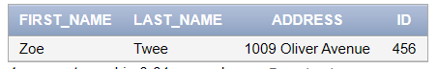

1. The following query was supposed to return the CD title "Carpe Diem" but no rows were returned. Correct the mistake in the statement and show the output.

SELECT produce, title

FROM d_cds

WHERE title = 'carpe diem' ;

→ SELECT producer, title

FROM d_cds

WHERE title like 'C%';

Result :

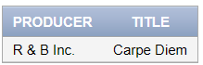

1. Write a SQL statement that lists the Global Fast Foods employees who were born before 1980.

→ SELECT *

FROM f_staffs

WHERE birthdate < '01/01/1980';

Result :



Atau

SELECT id, first_name||' '||last_name As Name,

birthdate

FROM f_staffs

WHERE birthdate < '01/01/1980';

Result :

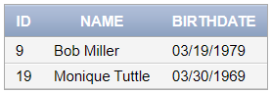

1. Display the first name, last name, and salary of all Global Fast Foods staff whose salary is between $5.00 and $10.00 per hour.

→ SELECT first_name, last_name, salary

FROM f_staffs

WHERE salary >= 5.00 AND salary <= 10.00;

Atau

SELECT first_name, last_name, salary

FROM f_staffs

WHERE salary BETWEEN 5.00 AND 10.00;

Result :

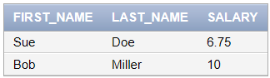

1. Select all the Oracle database employees whose last names end with “s”. Change the heading of the column to read Possible Candidates.

→ SELECT last_name as "Possible Candidates"

FROM employees

WHERE last_name LIKE '%s';

Result :

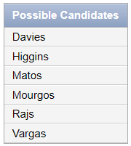

1. Write a SQL statement that lists the songs in the DJs on Demand inventory that are type code 77, 12, or 1.

→ SELECT *

FROM d_songs

WHERE type_code = 77

OR type_code = 12

OR type_code = 1

ORDER BY type_code;

Result :

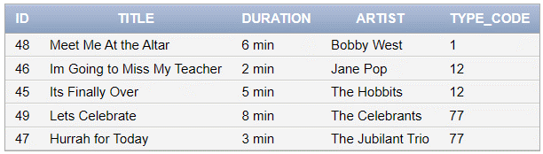

1. Write SQL statement that will produce the desired output!

Who am I?

I was hired by Oracle after May 1998 but before June of 1999. My salary is less than $8000 per month, and I have an “en” in my last name.

→ SELECT hire_date, last_name, salary

FROM employees

WHERE hire_date > '05/01/1998' AND hire_date < '06/01/1999'

AND salary <= 8000 AND last_name LIKE '%en%';

Result :

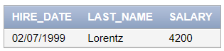

1. In the example below, assign the employee_id column the alias of “Number.” Complete the SQL statement to order the result set by the column alias!

SELECT employee_id, first_name, last_name

FROM employees;

→ SELECT employee_id as "Number", first_name, last_name

FROM employees

Order by "Number";

Result :

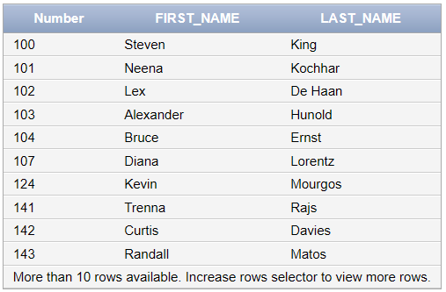

1. Order the DJs on Demand songs by descending title. Use the alias "Our Collection" for the song title.

→ SELECT title as "Our Collection"

FROM d_songs

ORDER BY title DESC;

Result :

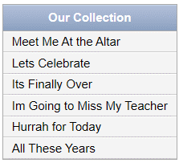

1. SELECT prefix

FROM phone

WHERE prefix BETWEEN 360 AND 425

OR prefix IN (206,253,625)

AND prefix BETWEEN 315 AND 620;

Which of the following values could be returned?

625, 902, 410, 499

→ 625